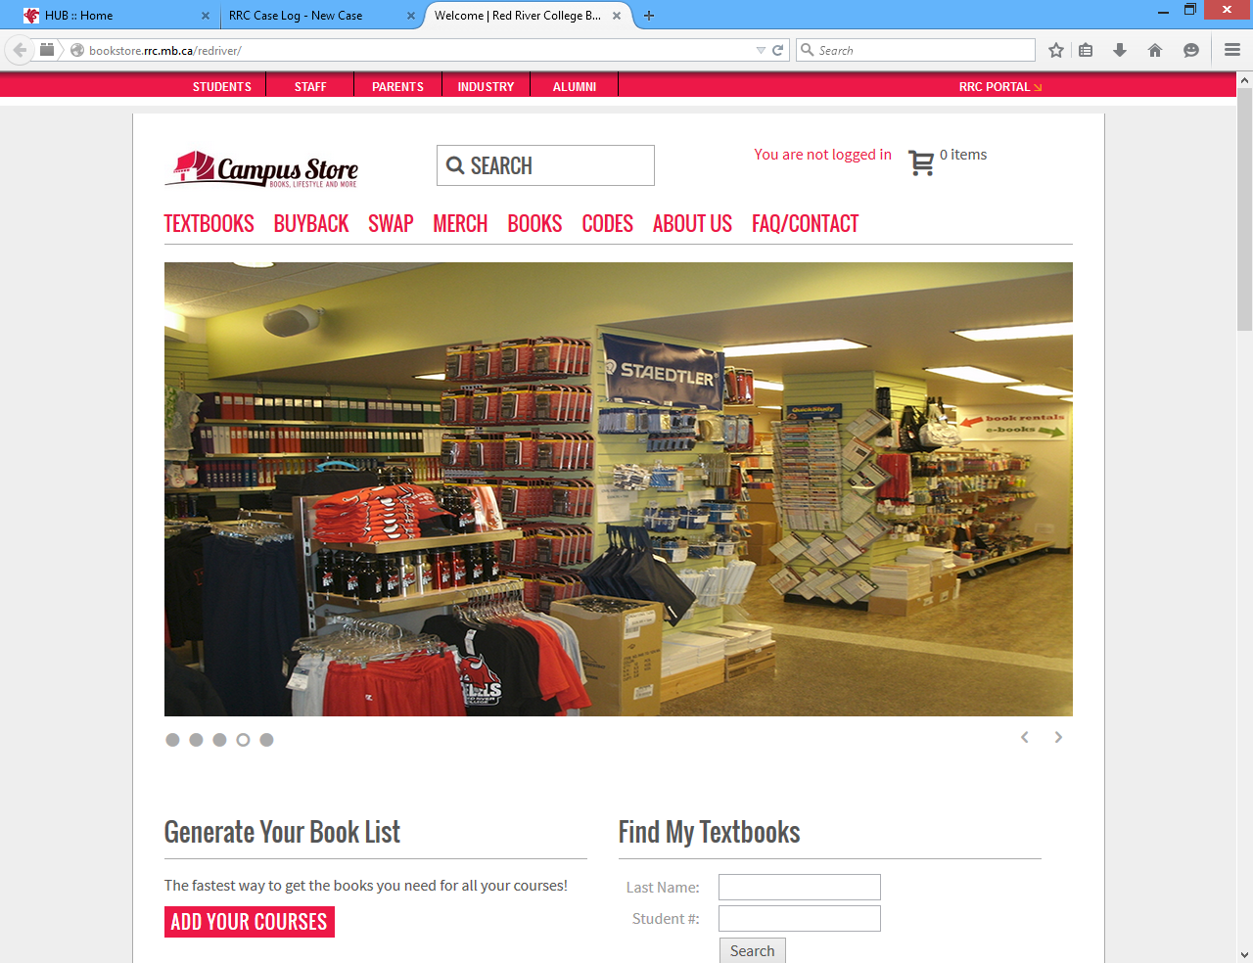
Go to Red River College Campus Store website: bookstore.rrc.mb.ca/redriver
SEARCH OPTION # 1: BUY / RENT TEXTBOOKS (when you do not know your student number)
ADD YOUR COURSES
Click on
ADD
Using the drop down Select your Campus / Department / Course / Section and click
The list of courses you have selected will appear below. Repeat until all courses you are taking have been added. Then click on
GET YOUR BOOKLIST YOUR COURSES
Now you can either order your books online or print the list and come into our store where we will help you find your books.
SEARCH OPTION #2: FIND MY TEXTBOOKS.
You must be registered (not just accepted) in the class for this option to be used.
SEARCH
Enter in your Last Name and Student Number and click on
The list of textbooks for all the courses in which you are currently enrolled will show.
Print the list and bring it into the Campus Store to purchase your books or if you wish to purchase your books online add the titles to your Cart and proceed to checkout.

