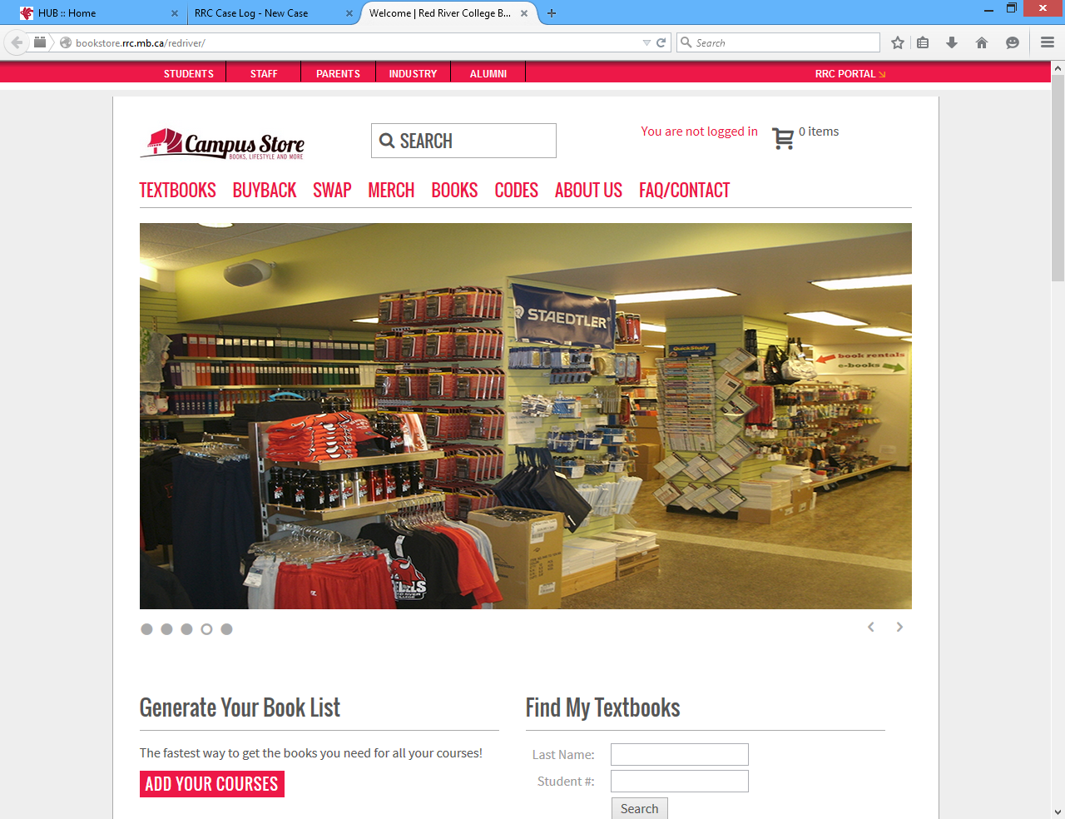
There are 2 methods to find the list of items required for your course.
SEARCH OPTION # 1: (when you do not know your student number or have not registered for the course).
GENERATE YOUR BOOKLIST
ADD YOUR COURSES
- Click
- Using the drop down Select: Campus / Department / Course / Section.
ADD
- Click
- Repeat until all courses you are taking have been added.
GET YOUR BOOKLIST
- Click
- The booklist for courses you have selected will appear.
- Print your list.
SEARCH OPTION #2: (when you know your student number& have registered for the course)
FIND MY TEXTBOOKS.
SEARCH
- Enter your Last Name and Student Number and click on
- The list of textbooks for the courses in which you are currently enrolled will show.
- Print your list.

The Campus Store receives an update of student registration information at 11:30 and 3:00 pm daily. During this time booklist information will be unavailable for approximately 15 minutes.
If you are on a waiting list for a course, option 2 may not be available to you.

